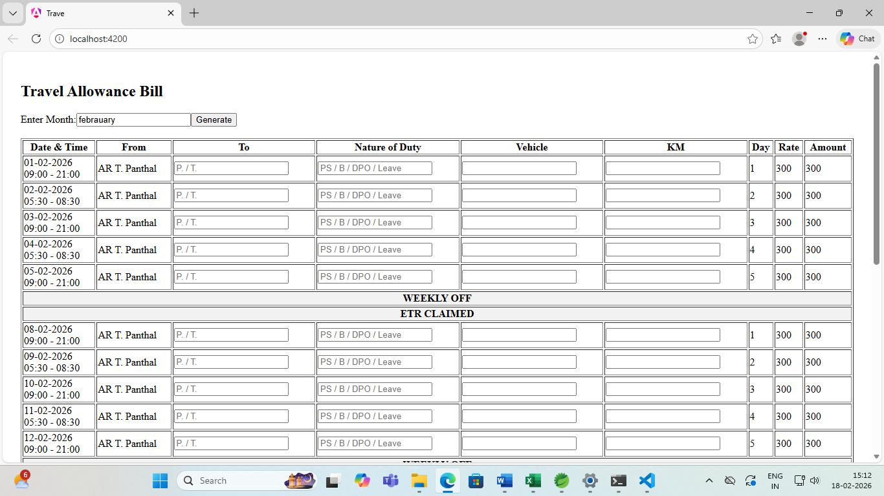
Annexure of Project
Project Name | Creation of TA BILL
Scope | In this days Armed Reserve Perambalur District has doing traval allowance bill in Excel . In Excel changing single correction the whole template to be changeable one that’s why i have to simple this by create TA Bill Project using Angular
Features | - In this Project When i am entering a month the whole day will be created with time  - Assuming working time has been same for monday, tuesday, wednesday has following some plans in morning hours of 05.30hrs to 08.30 hrs  - Remaining working days has been working hrs is assumed to 09.00 hrs to 21.00 hrs  - in this manner have some person doing DPO turnout duty this working hrs fully changed by and this has been assumed by entering DPO turnout duty working hours monday,wednesday, friday and sunday has assumed working hrs 09.00 to 21.00 hrs and remaining working days working hrs has been assumed to 18.30hrs to 21.45hrs  - Automatically changing Weekly off and ETR date by some one taking leave in the middle of the working days  - Automatically changing Weekly off, ETR when someone getting 4 days Feeding claimed The Count be restarted to 1  - Shortcuts also created To column when i pressing P. it is excuted to Perambalur so far T. is excuting Trichy. same as some shortcuts to be added in the nature of duty also

